

What On Earth?!
Easy Read Visual Story

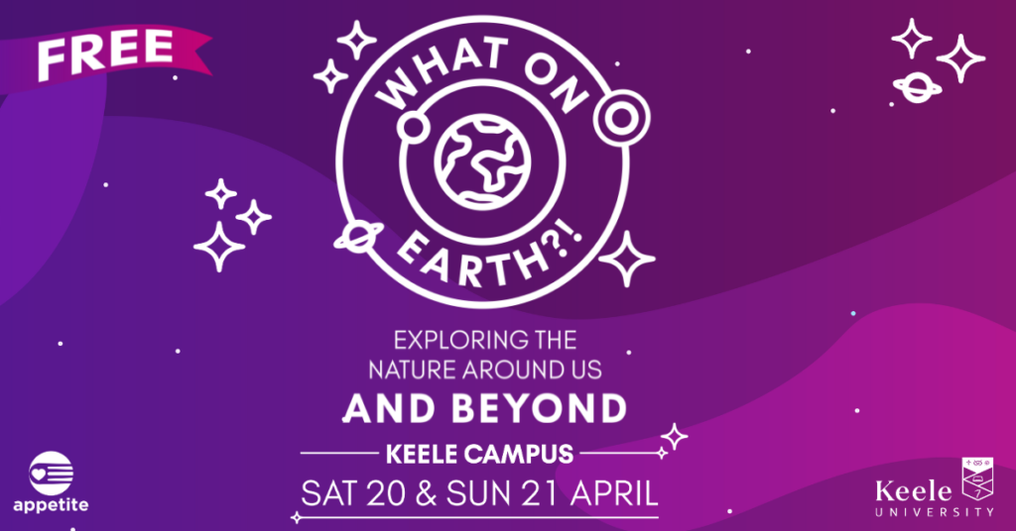

Programme Funders

Consortium
Event Partners


About What On Earth?!
 | What On Earth?! is a FREE event that is happening on Keele University Campus.
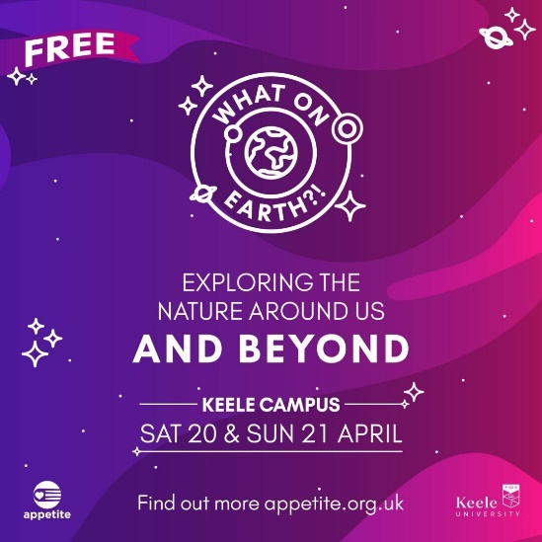 | At What On Earth?! you can have a go at lots of activities around the campus including:  - nature walks  - talks  - hands-on activities  - interactive art installations  - performances
 | What On Earth?! takes place on Saturday 20 & Sunday 21 April
 | The event will start at 11am
 | The event will end at 4pm
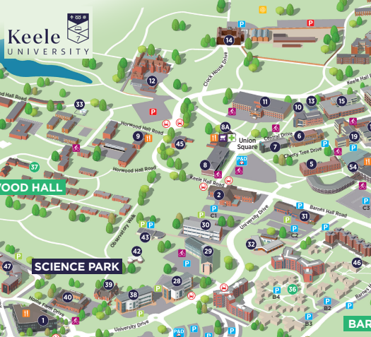 | What On Earth?! will be taking place at lots of different locations at Keele University campus.  Click to view a campus map:  https://rb.gy/wzq4es
 | Everyone is welcome at the event.
 | You can move around during the event.
   | You can leave and come back to the event.
   | Performers love it when you clap and make noise.

Finding Your Way at What On Earth?!
 | During the event you can ask for help.
  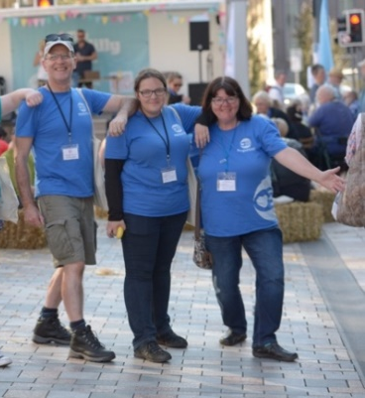 | Look for the people wearing this Appetite logo or blue Appetite clothing.  These are Appetite Stewards and are there to help.
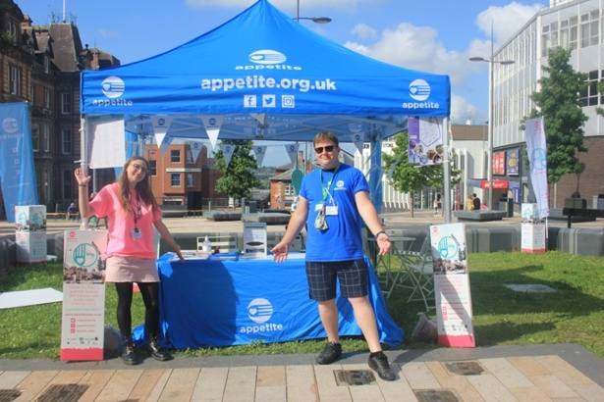 | The Appetite HQ can be found in Union Square.  You can go here for help and information.

Event Locations at What On Earth?!
 | The Sustainability Hub  also known as Home Farm.  You can find the Stardome here on Saturday 20 April.
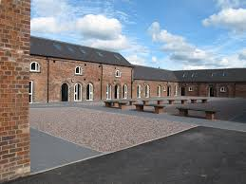 | Sustainability Hub Courtyard  The Dorodango Ball Making activity will happen here.
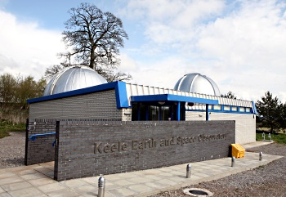 | The Observatory  Solar Observing will take place here.
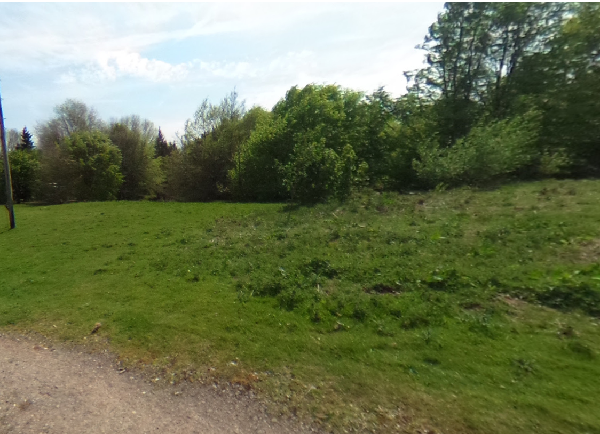 | The Meadow  (outside The Observatory)  You can Grow Your Own Poetry here.
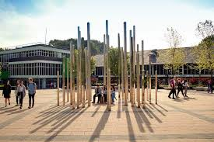 | Union Square  The Appetite HQ can be found here.  You can also write a pledge here.
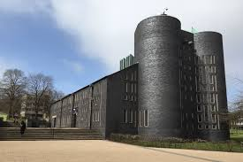 | Keele Chapel  Supersonic Gigs will take place here on Sunday. This is a bookable event.
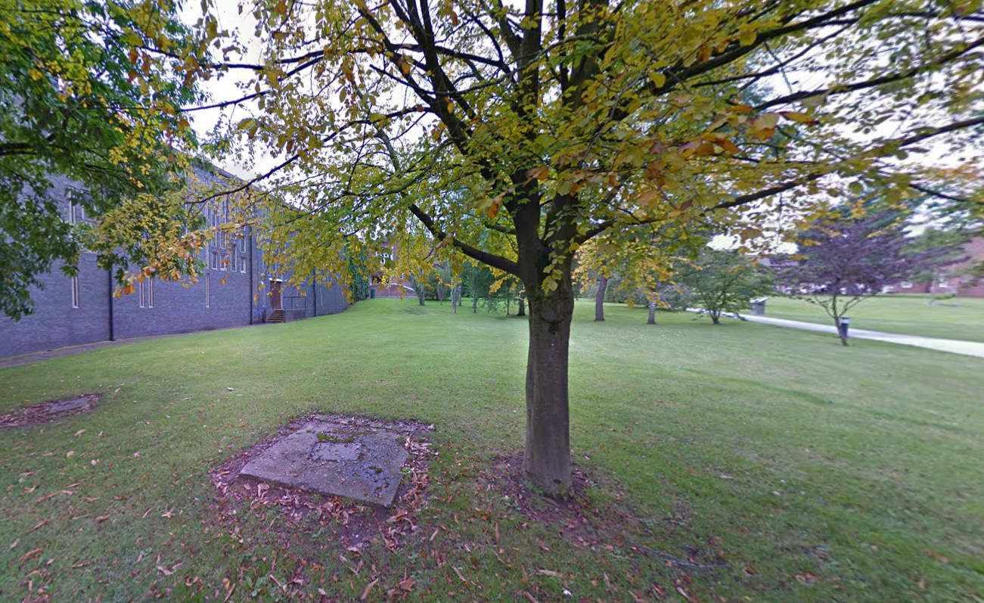 | Chapel Green  Sign Of The Times will take place here.
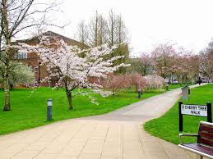 | Cherry Tree Walk  The Hidden Music Of Trees can be found here.
 | Keele Hall Gardens & Woods  Echoes Within The Earth will take place here on Saturday.
Access at What On Earth?!
If you need any help at the event, please speak to a member of the team.

They will be wearing blue Appetite clothing or look for the Appetite logo.
 | There is a wheelchair accessible route around campus.  Click the link: https://rb.gy/68qear  to view the map
 | Echoes Within The Earth will be Audio Described. You can collect headsets for this from the Appetite HQ in Union Square.
 | The event will have BSL interpretation as required.  You need to ask for this when booking any of the ticketed events.
 | Performances at the Event are relaxed.  You can:  - Wear headphones  - Make noise and clap  - Come and go  - Move around
 | Noise cancelling headphones are available to borrow from the Appetite HQ.
 | Accessible toilets can be found at the Students Union, the Sustainability Hub and the Chancellor’s Building (open on Saturday only)

