

Celebrate Newcastle
Easy Read Visual Story
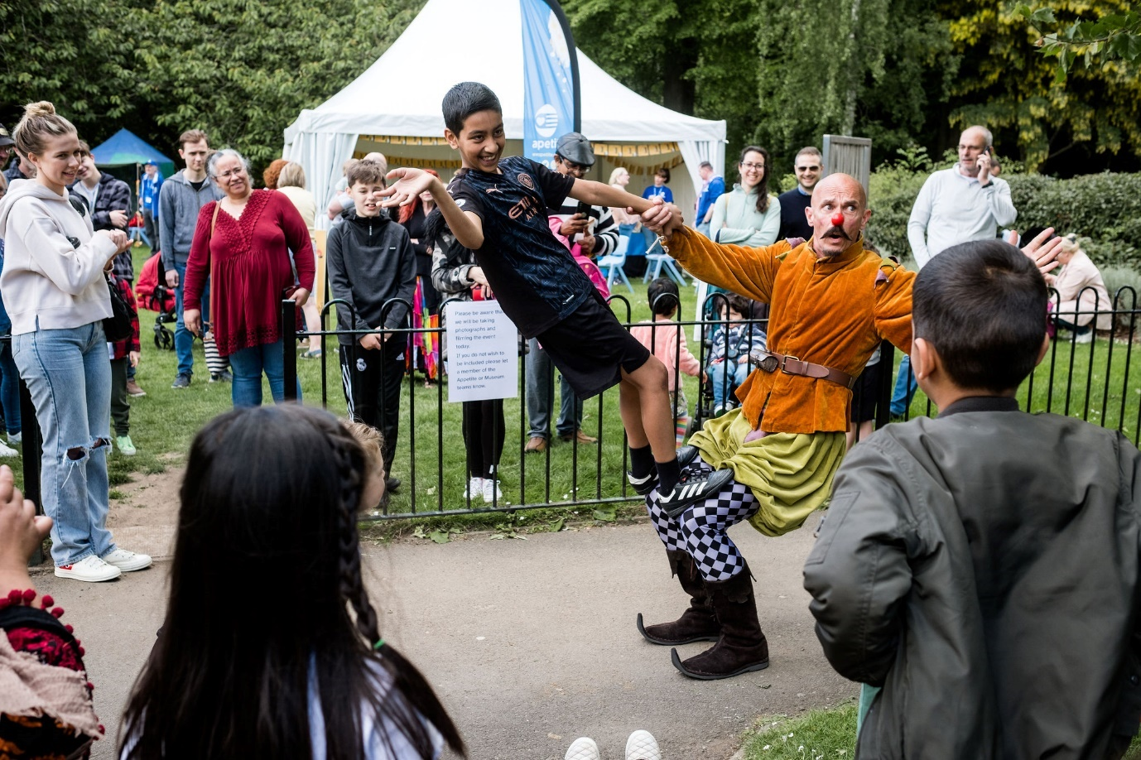


Event Partners
Consortium
Programme Funders
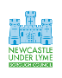
About Celebrate Newcastle
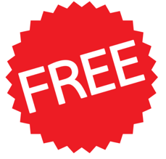 | Celebrate Newcastle is a free event that is happening at the Brampton Park & Museum.
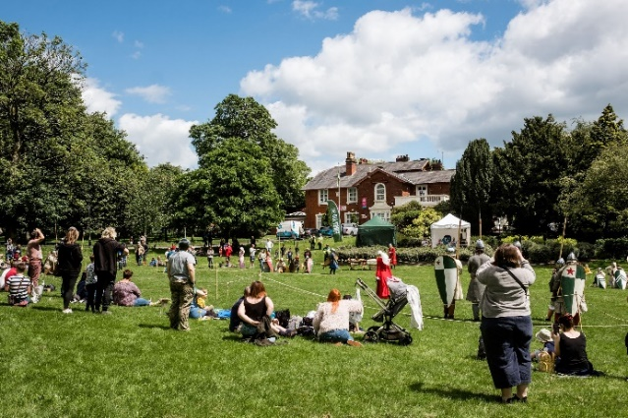 | Celebrate Newcastle is an outdoor event where artists and historic re-enactors appear in the Brampton Park and inside the Museum for people to enjoy.
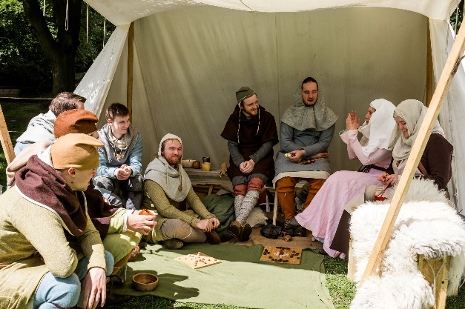 | Historic re-enactors dress up in clothes from years ago and act out what life was like.  There will be medieval re-enactors at Celebrate Newcastle.
 | Celebrate Newcastle is happening on Saturday 3 June
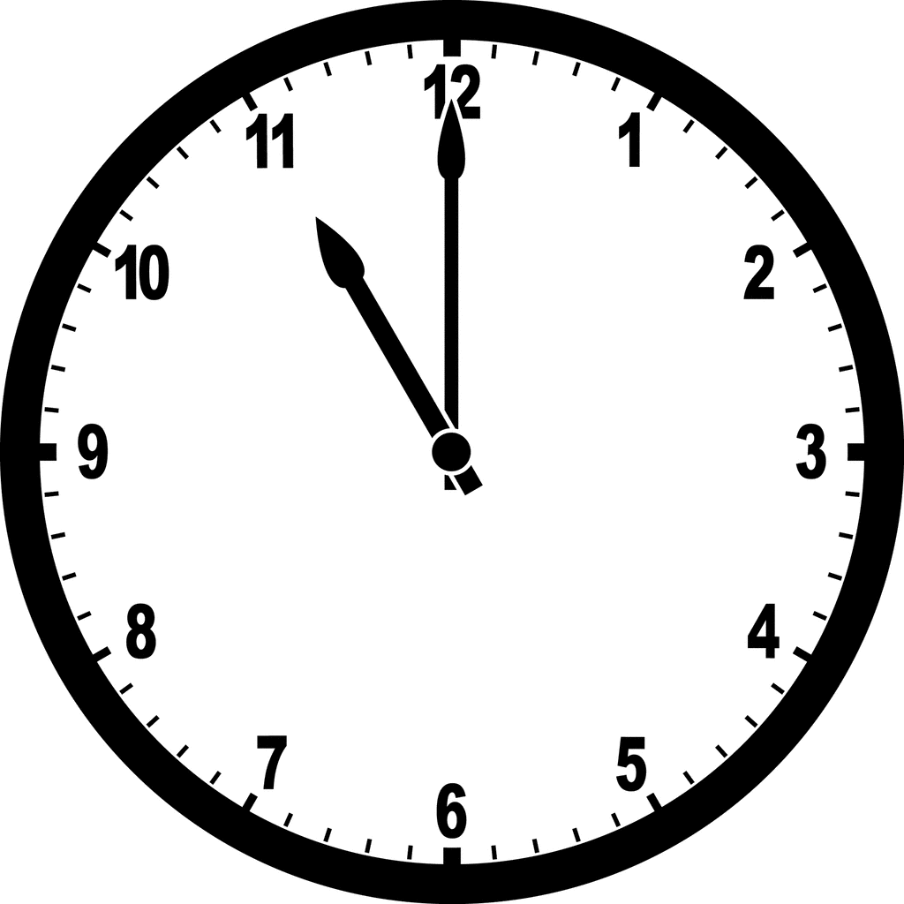 | The event will start at 11am
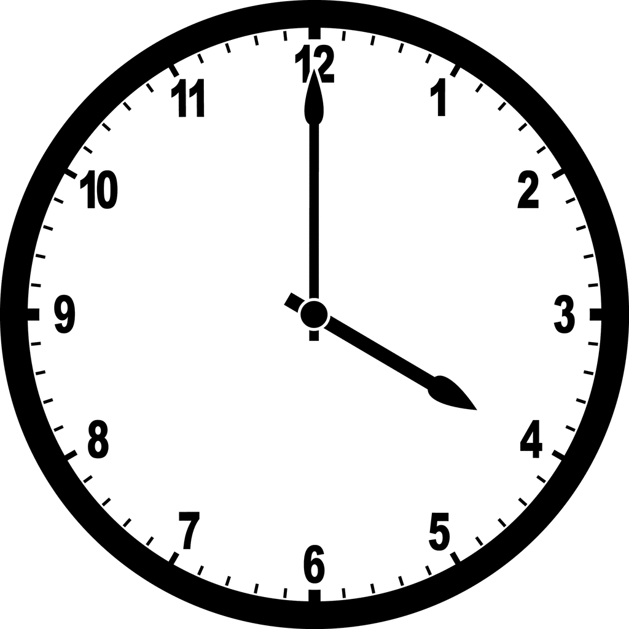 | The event will end at 4pm
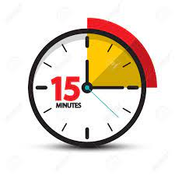 | Most performances last around 15 minutes.
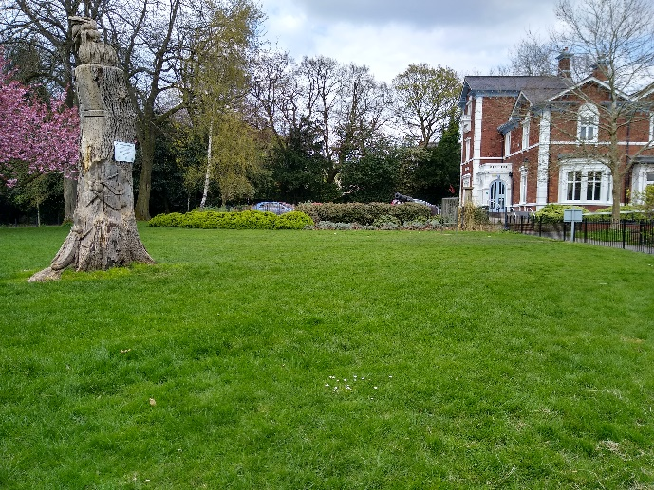 | Celebrate Newcastle will be taking place in the park and inside the Museum.
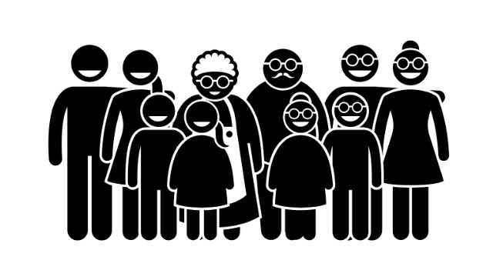 | Everyone is welcome at the event.
 | You can move around during the event.
   | You can leave and come back to the event.
   | Performers love it when you clap and make noise.

Finding Your Way to Celebrate Newcastle
 | During the event you can ask for help.
  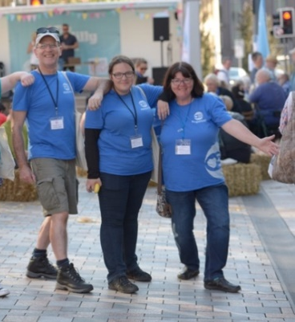 | Look for the people wearing this Appetite logo or blue Appetite clothing.  These are Appetite Stewards and are there to help.
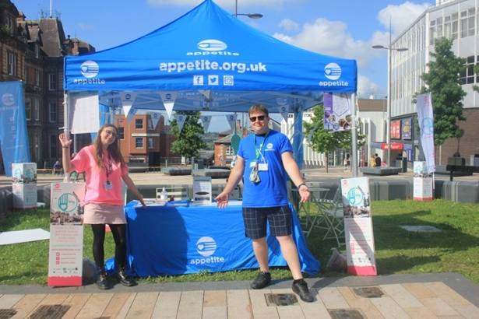 | The Appetite HQ will be  On the grass near to the Museum entrance. You can go here for help and information.

Event Area at Celebrate Newcastle
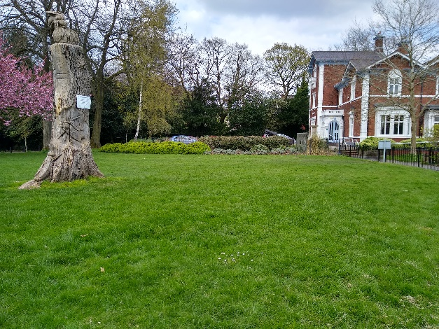 | Grassy Area next to the museum entrance
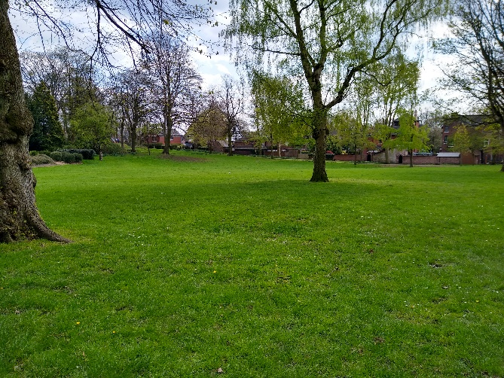 | Main park grass area
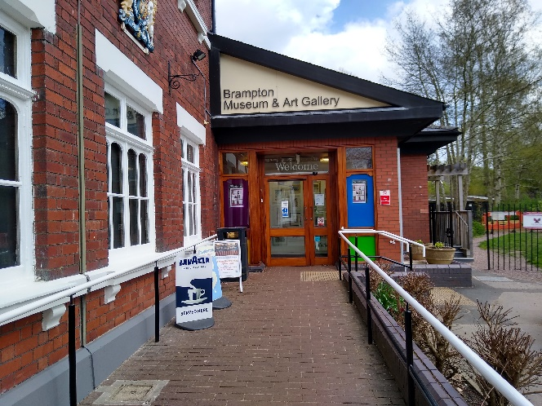 | Inside the Museum
Access at Celebrate Newcastle
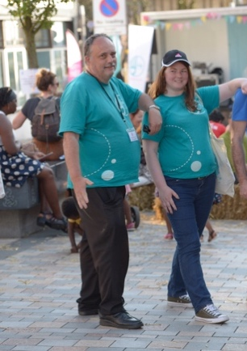 | There is an Access Team at the Celebrate Newcastle event.  They can help you and answer any questions.  Access Stewards will be wearing a green T-shirt.
 | Performances at the Event are relaxed.  You can:  - Wear headphones  - Make noise and clap  - Come and go  - Move around
 | Noise cancelling headphones are available to borrow from the Appetite HQ.
 | The event is wheelchair accessible. Mats will be placed on the grass.
 | Some performances will be Audio Described, you can an Audio Description Kit for these from the Appetite HQ.
 | The event will have BSL interpretation.
   | You can ask the Access Team for help if you need to.
 | Accessible toilets can be found in the Museum.

